

**Purchasing Manager Position**

The Purchasing Manager Role

A purchasing manager (BDM) works under the guidance of the Regional Franchisee and is field based however an office base is supplied at the local District Franchisee office enabling the purchasing manager to integrate with the team and gain valuable knowledge of the local business needs.

Primarily the role is to recruit new clients to the exchange who fit our profile and who can supply goods and services to other clients through the BBX currency. In addition to this role the Purchasing Manager should keep in regular contact with his clients in order to stimulate the client as an ambassador and also to grow the network around the client’s needs.

Remuneration

The role is a self employed position and is remunerated by way of the following three income streams:

1. 20% of the initial Annual Card Fee paid by the client.
2. 50% of any initial Lifetime Marketing Fee or upgrade of account.
3. A residual income of up-to 20% of the ongoing trading fees on all clients enrolled by the Purchasing Manager from his own generated leads.

Note that a basic retainer up to £20,000 pa is incorporated in this role payable monthly and measured against work activity.

BBX Account levels

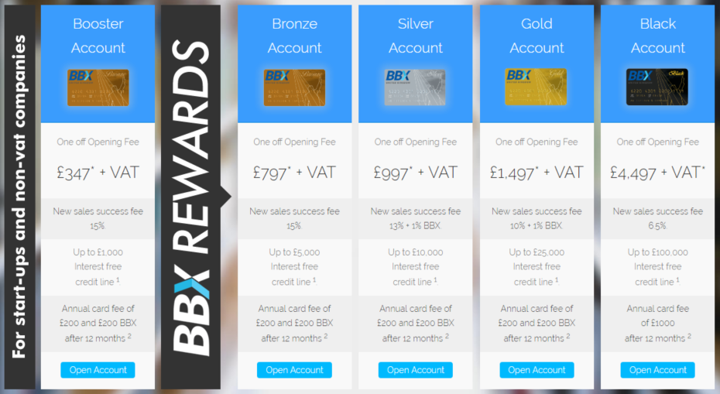

Ambassador Income Levels

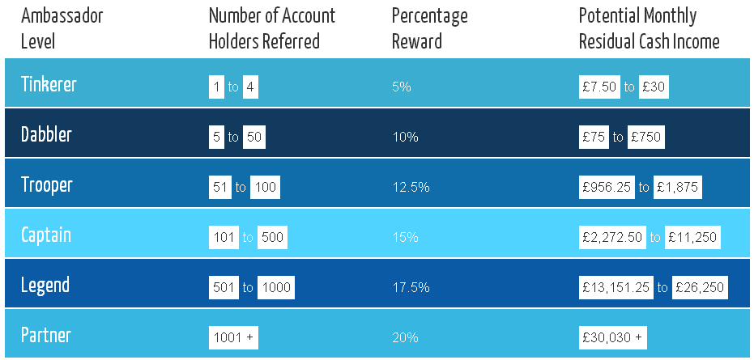

Income Illustrations

Below are some income illustrations based on assumed performance. Target levels of new clients are 20 per month however the range based on work output and skill would be between 10 – 50 sales per month.

**Enrolment Commissions**

|  |  |  |  |  |  |
| --- | --- | --- | --- | --- | --- |
| **Scenario** | **Number of new** | **Mix of accounts** | **Monthly Comms** | **Yearly Comms** | **Extra BBX£** |
|  | **clients a month** |  |  |  | **Per Year** |
| 1 | 10 | 20% Booster 60% Bronze 20% Silver [ for this calculation ] | 3935 | 47220 | 2400 |
| 2 | 15 |  | 4701 | 56412 | 3600 |
| 3 | 20 |  | 6270 | 75240 | 4800 |
| 4 | 25 |  | 7836 | 94032 | 6000 |
| 5 | 30 |  | 9405 | 112860 | 7200 |
| 6 | 35 |  | 10971 | 131652 | 8400 |
| 7 | 40 |  | 12540 | 150480 | 9600 |

**Ambassador Commissions** (assumes fees @ 12% and sales @ BBX500 per client)

|  |  |  |  |  |
| --- | --- | --- | --- | --- |
| **Year** | **Number of clients enrolled per month from own leads** | **Number of clients c/f assuming 2% loss**  **Per month** | **Ambassador Level** | **Yearly Ambassador Income Projection** |
| 1 | 15 | 147 | Captain – 15% | 15940 |
| 2 | 15 | 268 | Captain – 15% | 29012 |
| 3 | 15 | 367 | Captain – 15% | 39730 |
| 4 | 15 | 449 | Captain – 15% | 48520 |
| 5 | 15 | 515 | Legend – 17.5% | 65015 |
| 6 | 15 | 570 | Legend – 17.5% | 71910 |
| 7 | 15 | 615 | Legend – 17.5% | 77563 |